### *[Woman Reclining in a Hammock](https://artsandculture.google.com/asset/woman-reclining-in-a-hammock/3wE2zvgRvCWStA)* [by İbrahim Çallı (1882-1960)](https://artsandculture.google.com/asset/woman-reclining-in-a-hammock/3wE2zvgRvCWStA)

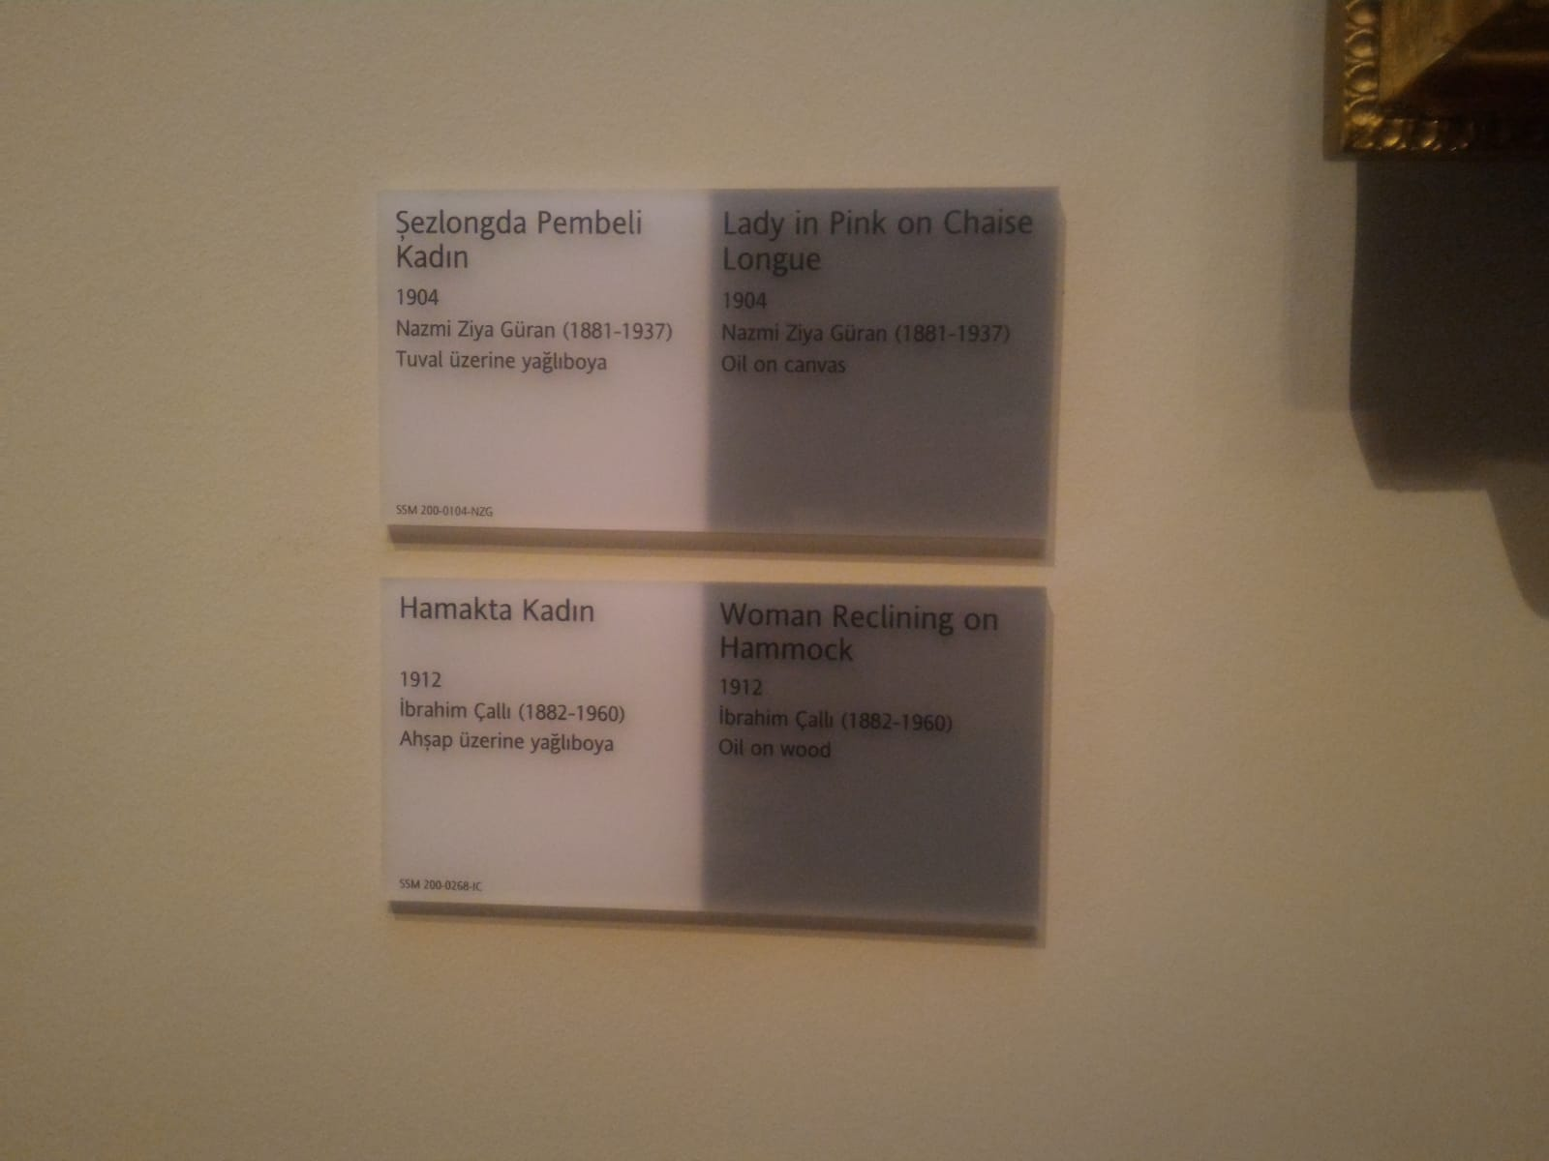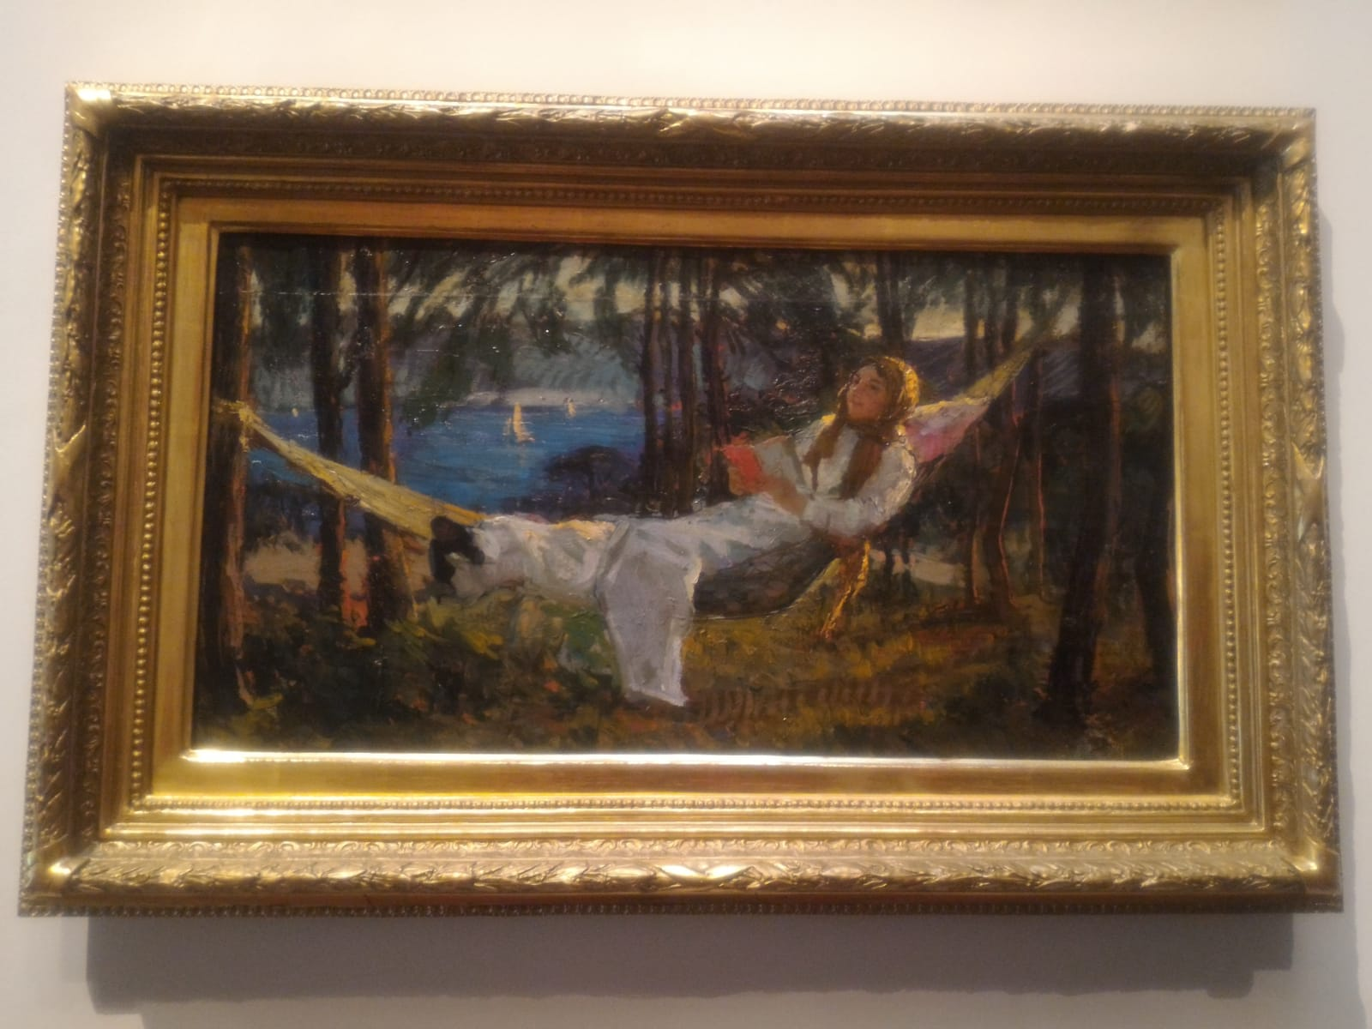

This significant impressionist work of art that depicts the youth, nature, and beauty is painted by Ibrahim Calli. A Turkish artist who is born in the town of Çal and later moved to Istanbul as a young male. This “Woman Reclining in a Hammock” original art is made in 1912 and can be found today in the Sabancı University Sakıp Sabancı Museum (Emirgan, Istanbul, Turkey). This exceptional museum was founded by Sakıp Sabancı in June 2002 and is dedicated not only to Ottoman era paintings but also calligraphic and religious art, as well as state documents. The audience targeted by this painting is the Turkish women but it can go further to say all women in general who have an appreciation for beauty, nature or intellect. The technique and material used is oil on wood. In addition to that, the size of the painting is 38 x 70 cm.

In this astonishing paintwork, we observe a woman dressed in a white lengthy dress with long sleeves, a brownish headscarf and well painted black shoes reclining on a hammock. While relaxing, she’s holding a half orange half white book firmly with both of her hands. Her legs are crossed and her gaze is, assumably, to the sky. Behind her is nature. She’s beside the seaside with multiple thin trees surrounding her background. Visible in the sea are sailing boats and in the distance we observe mountains.

The use of art elements is evident in this artifact. We notice the implied balance of the girl on the hammock. In addition to that, the trees are painted by implied lines and her gaze towards the sky makes up psychological lines. The way the artist paints his implied lines can even suggest the texture of the dress material. This naturalistic outdoor scene artwork almost looks unfinished, as if someone only caught a glimpse of it, which suggests the style of impressionism. The use of such naturalistic colors in this impressionistic style creates a very calm and serene environment. The whiteness of her dress emphasizes her figure and we automatically focus on her then the hammock and not the nature background. This dynamic interrelationships between these various art principles and elements produce this beautiful Turkish artwork.

The style used is impressionism, a 19th-century art movement. The artwork captures the girl in a hammock without realistically finishing his painting. Ibrahim Calli perfected the style of impressionism. He communicates to the viewers a pretty, beautiful and awe taking figure and a calm emotion by using the impressionistic art style. Impressionism is a movement that consists of a new representation of reality and begins a turning point in the art of the time.

We can conclude that since Ibrahim Calli used the style of impressionism that he might be one of the Turkish artists that were greatly influenced by Monet. We are only making the assumption based on art historians lack of knowledge about Turkish impressionists in that period of time. The painter, Claude Monet, was born in Paris in 1840 to a merchant father of colonial descent. Back in France, and despite the criticism of the artistic circles, he and his friends did an exhibition where he presented his canvas "Impression Soleil Levant" (1872) which gave its name to Impressionism. But he sold few paintings and lived in great poverty and this lack of finances forces him to move away from Paris. When looking at Ibrahim Calli’s work especially this « Woman Reclining in a Hammock » art piece, it might remind the viewer greatly of one of Monet’s greatest works. It is the painting by the title « Woman with a Parasol »

It is said in the fundamentals of context and analysis that «Artworks communicate visual ideas, just as speaking and writing communicate verbal ideas. For the transfer of thought to take place through art, we must interpret the visual language of the artist. This involves analyzing the way he or she has created the artwork. »

When analyzing this artwork, the date and place of its making become really important. When looking back at the history of Turkey in 1912, we find the Italian-Turkish war to overtake North Africa, especially in today’s Libya. Italian-Turkish war or as the so-called Libyan war refers to the battles between the Italian forces and the Ottoman Empire between 28 September 1911 and 18 October 1912 to occupy both Tripoli and Barqa. The Italian colonial ambitions led to the overtake of the provinces of Tripoli and Bireka from the Ottomans. At that time, although the Ottoman emperor had a modern fleet, he felt the danger of the situation for fear of the failure of his forces in front of the Italian forces. The army and aviation did not have advanced weapons and military techniques. The "sick man of Europe" is a title known to the Ottoman Empire after this defeat.

The artist by painting this woman on a hammock gives hope for better times. In art, the female is always seen as a symbol of revolution and awareness. The book in her hand further suggests intellect, self-respect, and Ottoman culture.

The "sick man of Europe" is a title known to the Ottoman Empire after it was at the height of its glory, and it controlled many places in the world. However, the preoccupation of the Ottoman rulers with the rule of other things and the successive defeats inflicted by the Europeans on the Ottoman armies led to the spread of weakness and disintegration. This name was later popularized and used by other European countries.

This painting is contradictory of this «sick man » because it showcases a strong independent young hopeful woman. In my opinion, the hammock indicates happiness and the shores of midstream sea further suggest peace between the two seashores. The Turkish painter Ibrahim adds his unique touches to the impressionistic art like the headscarf surrounding her head to showcase his own traditions and culture. Since in his youth he lived through wars and witnessed the weaknesses of the Ottoman empire, Ibrahim utilises his artwork to portray a positive image for the future of Turkey. After doing research, I think that his other artwork is just as significant since it shows the importance of women and how to solve the ottoman crisis at his time.

**References**

"Catalogue." *The Art Institute of Chicago Quarterly* 51, no. 2 (1957): 33-34. http://www.jstor.org/stable/4120396.

"Treaty of Lausanne." World War I Document Archive. Accessed December 11, 2018. https://wwi.lib.byu.edu/index.php/Treaty_of_Lausanne.

Republic of Turkey Ministry of Foreign Affairs. (2018). *From Rep. of Turkey Ministry of Foreign Affairs*. [online] http://www.mfa.gov.tr/speech-entitled-_vision-2023_-turkey_s-foreign-policy-objectives__-delivered-by-h_e_-ahmet-davutoglu_-minister-of-foreign-af.en.mfa [Accessed 11 Dec. 2018].

Fichner-Rathus, L. (2012.) *Understanding Art*.